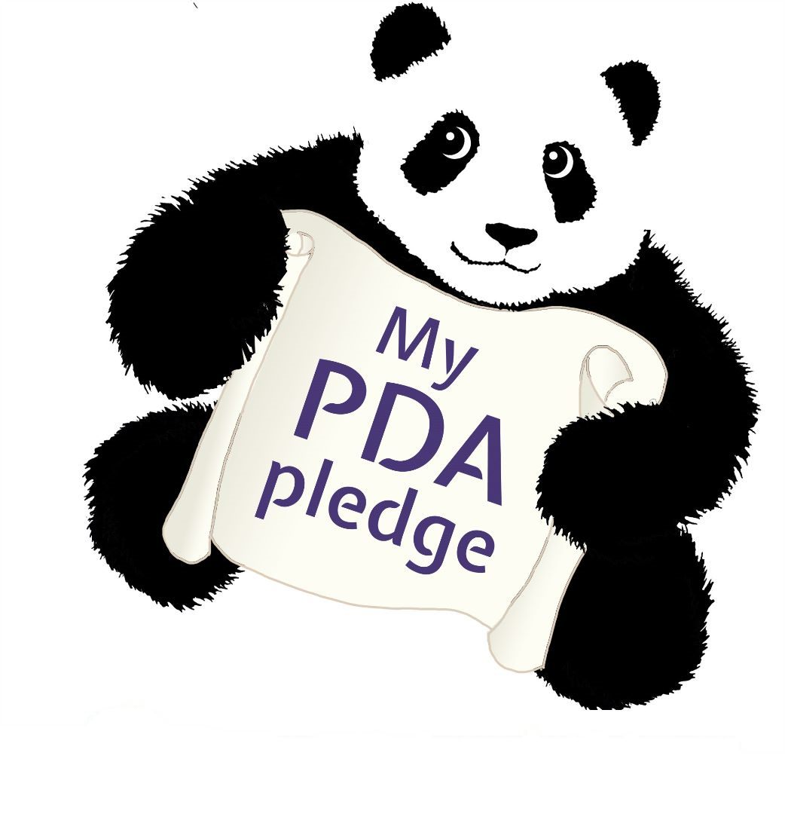

|  |
| --- |
| **My PDA pledge …** |
| **Signed** |