Request for reasonable adjustments to be made for (my child)

What are we hoping to achieve together for (my child)?

(My child)’s point of view
(My child) has said he/she wants to keep going to XX School because he/she loves seeing his/her friends there and he/she really likes some of the teachers. The only thing preventing him/her wanting to go is fear of punishment – for not doing his/her homework, for talking in class etc. These are both things that he/she has great difficulty with due to his/her developmental disability. If he/she could be assured that the fear of these punishments happening to him/her could be removed, he/she feels he/she would be happy at school.

Parental point of view
We would like (my child)’s increased levels of anxiety regarding secondary school to be minimised, so that he/she can attend willingly and feel calm enough to be able to concentrate well in lessons, in order to make the progress he/she is capable of. We would also like his/her anxiety at school to be minimised so that when he/she comes home we are only dealing with the usual amount of stress release one would expect from an autistic child, rather than the highly exacerbated levels that have been displayed since starting at secondary school. We are very grateful to the school for the support you have shown (my child) so far since he/she started at XX School, in terms of providing him/her with a mentor and trying to minimise his/her worries at school, and feel that just a little additional flexibility on behalf of the school would make a massive impact on his/her wellbeing.

Core adjustments
We would like three core adjustments to be made for (my child) by all staff that come into contact with him/her, in order to enable him/her to thrive at school and to prevent escalation of the high risk he/she is showing of developing harming behaviours. These adjustments are very achievable and will cost the school nothing in terms of extra support etc, but would make the world of difference for (my child) and us as his/her parents.

- Please could all staff who come into contact with (my child) make an extra effort to build a positive relationship with him/her, as others have already done. This will mean avoiding any use of judgemental, raised voice or negative tone or facial expression. This is because an element of (my child)’s presentation of ASD involves him/her having a highly sensitive nervous system which is particularly triggered by perceived threats, such as people’s interactions seeming at all hostile. This includes the use of negative phrases, tone, volume, facial expression and body language generally. Included below is some further info around using declarative and positive language with children with a demand avoidant profile of autism.

- Please could all staff agree to use no form of punitive discipline with (my child). This includes detentions, or any discipline techniques that involve shaming him/her, such as standing up in front of others, being reprimanded in front of others etc. This is the thing that induces the greatest anxiety in (my child). He/she does not present with any real behaviour problems in school, but finds it hard to manage him/herself in terms of organisation and to stop him/herself talking when he/she is meant to. Both of these issues can be dealt with by using neutral, declarative language and a quiet, friendly reminder of whatever he/she needs to do.

- Please could all staff remove the expectation from (my child) that he/she will undertake homework. Homework places a massive extra burden on (my child)’s time at home, when he/she is already offloading the stress of conforming to others’ expectations all day/week. The panic about having to do this, combined with his/her huge demand avoidance and difficulties in executive functioning mean that what should be (my child)’s recovery time is instead taken up with trying to get him/her to do something he/she just cannot do at that time, leading to terrible issues at home. We understand this could possibly impact on his/her academic outcomes, but the priority at this stage is his/her mental health and keeping him/her attending school.

(My child)’s difficulties/needs
(My child) is diagnosed with ASD with demand avoidance, (sometimes known as PDA, Pathological Demand Avoidance) which means he/she often experiences extreme anxiety when he/she does not feel in control within a given situation. He/she finds it very hard to be directed to do things, therefore school generally is difficult for him/her. He/she has learnt how to fit in at school and covers up most of his/her feelings and behaviours, but this masking is exhausting for him/her and takes its toll at home. He/she can also find it difficult to interact successfully with others at times.

His/her paediatric assessment shows excellent auditory recall, but difficulties in processing - he/she may appear to be listening, but might not have understood exactly what was said. Therefore he/she needs instructions to be very clear and simple. However, due to his/her demand avoidance, he/she needs declarative language to be used rather than imperative. His/her paediatrician suggests PDA strategies be used with him/her. I attach an overview of PDA written for schools.

He/she has difficulties with executive functioning, meaning he/she finds it difficult to be organised, forgets and loses things easily, and needs lots of scaffolding to manage his/herself independently on a daily basis. He/she is currently also under observation for ADD, due to displaying many difficulties with executive function: organisation, working memory, impulsivity, focus, distractibility etc.

Some of the challenges (my child) experiences, presented from his/her point of view:

- Anxiety
I will not show this on the outside, for fear of being judged, but most of the time I am existing in a state of high anxiety. This mainly comes out at home. The thing that makes me most anxious at school is getting into trouble, especially publicly, and feeling like people are angry with me. Being put on the spot, by someone who seems hostile to me, however mildly, cripples me with fear, though I will cover it the best I can.

- Demand Avoidance
The way people say things to me makes a big difference - it’s the way my brain responds to requests and not a behavioural problem. If I am asked in an indirect way I am more likely to be able to do something (eg ‘I wonder how much you can get done (my name)’ will make me feel far less stressed than ‘Come on (my name), hurry up’).

- Concentration
I find it really hard to concentrate on something that isn’t of my own choosing or of real interest to me. Listening for long periods is especially hard for me. Fiddling or stimming in another way makes it easier for me to concentrate.

- Processing
I find it hard to infer what someone means if they are not very explicit or clear. However, giving clear instructions in an overly firm way will also trigger my anxiety and then I will find it extra hard to concentrate and follow instructions.

- Impulse control
I find it very hard to stop myself from talking – especially when I’m stressed, excited or nervous. It is a kind of stimming for me that it is really hard to stop. You can tell me to sit still or stop talking, but the behaviours may reappear within minutes, so I may need constant patient reminders, and no escalation in anger.

- Eye contact
I can make eye contact, but unless I’m really relaxed I find it very difficult and uncomfortable. It means that all my focus will be taken up with trying to maintain eye contact, and I will find it harder to listen and concentrate on the speaker.

- Difficulties with friends
I really like being with friends but I can be controlling or reactive. I sometimes need help so that situations with friends run smoothly.

- Emotional self-regulation
If something goes wrong for me, I am not able to manage my upset and bring myself back to a state of calm easily. It is a kind of stress breakdown though it may appear to be over something very insignificant. In these situations I need someone to co-regulate me, by calmly acknowledging my upset, and then modelling strategies with me to help me calm down, such as gently helping me to see that it isn’t an emergency and helping me to move on.

- Sensory needs
I can find certain sensory experiences intolerant – especially sudden loud noises, or the feeling of uncomfortable fabrics. I feel pain from things more easily than others, so it can seem that I’m making more fuss than is necessary about small injuries etc. Most of my sensory needs, however, are related to my heightened emotional sensitivity.

What works/how teachers can help me…

- Understanding that I mask my anxiety and although I may appear calm and fine on the outside, this does not mean I am actually feeling it inside. I have learnt to cover my real feelings at school as I want to fit in and not get into trouble. It’s hard to hold your real feelings in and pretend to be something you aren’t all day and that takes its toll on me when I get home. Home is the only place where I feel I can let my real feelings out.

- Building a good relationship with me is the best way to help me feel less anxious and to behave and learn at my best.

- Show you like me, by smiling and connecting with me positively when you see me. I respond really well to feeling liked and valued. Please try not to criticise me or say negative things to me as I will feel that you don’t like me.

- Tone of voice and facial expression are really important to me as I read a lot more into them than others. Please only ever use a calm, pleasant tone of voice with me, even if you are needing to tell me off, please do it as a warm, friendly reminder, rather than in a cross or harsh voice. Please avoid making sudden loud noises like shouting at me as this makes me really anxious.

- Avoid punishing me by doing anything that shames me in front of other people. Eg detentions, making me stand up in front of others, telling me off in front of others. This is my worst nightmare and it is my biggest fear in school. Please just speak quietly to me on a one to one basis instead as sometimes I need help to remember to focus carefully on things.

- Use neutral language/non-judgemental language with me as this puts me at ease and will help me to focus on what you are actually saying rather than how it’s making me feel. Sarcasm and criticism immediately escalate my anxiety levels.

- Deliver instructions calmly and try not to make them sound like a command as this instantly escalates my anxiety – eg ‘would you mind coming up with a good way to make sure you remember your pencil tomorrow’ is a good way to phrase things for me.

- Limit direct questions as these feel like demands and the pressure can feel very anxiety provoking. Rewording in authentically non-direct ways such as ‘Would you be happy to share your thoughts?’; ‘I’m wondering whether you ….’; ‘I notice that…’; ‘I was thinking you could…’.

- Teach me specific strategies for the behaviour you want to see. I don’t have natural self-organisation strategies and need clear but calm explaining of the steps I should take. I find it easier to learn these in the structured environment of school than I do at home.

- Let me know if there is a change in planned routine happening. I struggle with too much enforced structure and routine, but I like to know what is happening when, and it helps me if I am warned if there is a change in routine if at all possible.

- Give me processing time when asking me questions or when giving me instructions. Don’t get impatient with me or I will sense it and will be flooded with stress hormones which make it even harder to think straight.

- Don’t force me to make eye contact as a way of showing I am listening – it makes it harder for me to listen if I have to make eye contact when I feel uncomfortable with it.

- Please don’t force me into anything I do not feel ready or comfortable doing. I’m always pushing myself out of my comfort zone but only when I feel in control of it and relaxed, I will usually give most things a try when I feel ready to.

- Giving me some control by offering choices; this always makes me feel more relaxed and motivated.

- Please be patient and understand this is harder for me than it is for those dealing with me.

What to do if I panic…

- Offer sympathy, acknowledge the fear/anxiety and why you think I have it. Tell me we can find a different way.
- Offer a quiet space, ideally someone I feel safe with should stay.
- Wait and give me time. Talk about it later when I am calm.

Why the way (my child) is spoken to makes so much difference to (his/her) wellbeing and ability to learn:

Non-PDA friendly language includes direct questions, prompts and demands. This form of communication puts immense pressure on the PDA listener and it can feel very anxiety provoking. Children with PDA benefit greatly from tone and language adaptations which reduce the perception of demand. Declarative language is a form of commentary which shares information in a relaxed, open way. Rephrasing things to talk about the object or environment rather than the person can also work well – e.g. instead of ‘you need to start your work now’ you could say ‘the work is ready’ or instead of ‘could you come this way please’ you could smile, gesture and say ‘the room is through here’.

Further information regarding Pathological Demand Avoidance (PDA)

A representative from the PDA Society would be very happy to talk to the school if it were felt helpful. Below are some excerpts taken from the Teachers’ section of the PDA Society’s website which can be accessed here: www.pdasociety.org.uk/education/teachers-guide and on the next page is an infographic summarising the helpful approaches for a PDA profile of autism.

“Pathological Demand Avoidance (PDA) is now widely recognised as a distinct profile of autism which presents in some children on the spectrum. Children with a PDA profile will share similar difficulties to others on the autism spectrum in areas of Social Communication Social Interaction and Restrictive and Repetitive patterns of behaviour (including sensory seeking or sensory avoiding behaviour.

Children with PDA can appear to have better social understanding and communication skills than others on the autism spectrum, which means that some of their difficulties may be less obvious at first. But their understanding of such matters may not be as good as it seems and may be due to the child imitating, copying and therefore role playing what they perceive to be the correct social responses. Consequently their autism may often be missed with the focus instead being placed on a child's external presentation 'only' which can lead to misunderstandings regarding the underlying cause for these difficulties.

The overriding state of the child’s approach to school and learning is one of anxiety, which for a number of children impacts on their willingness to come to school in the first place (the ultimate avoidance). It is also important to note that the behaviour of a child with a PDA profile of ASD can vary between settings or at different times and with different people e.g. a child can be anxious at home, but appear calm at school. This may be a coping strategy for the child and, as with other children on the spectrum, some children with the PDA profile are able to ‘mask’ i.e. hold in their anxieties.

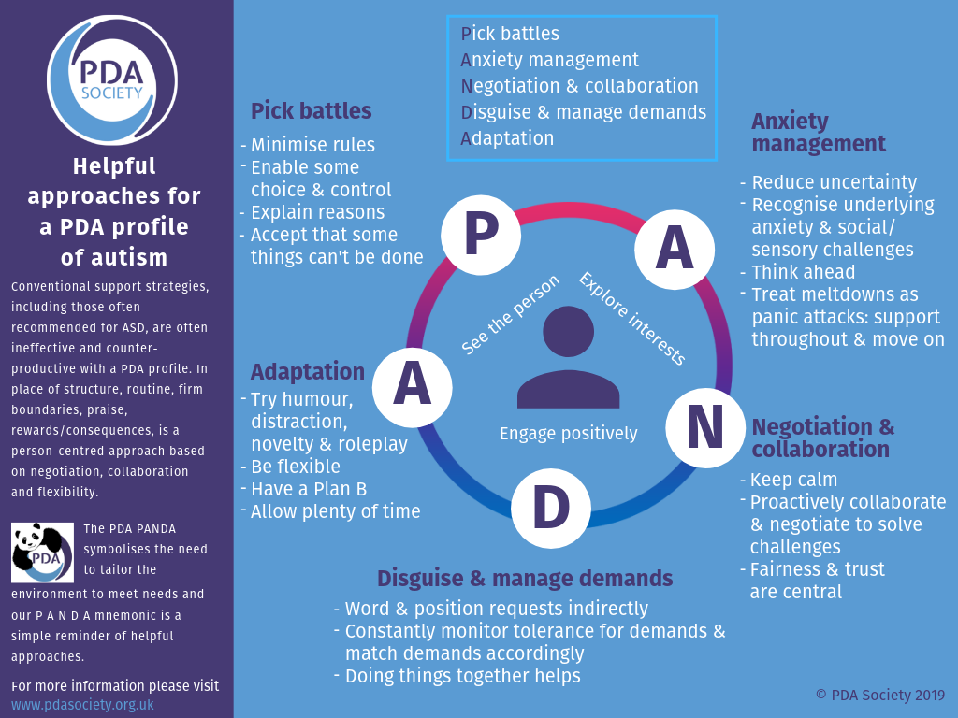
When a child masks their difficulties and anxieties it may sometimes result in parents feeling isolated and misunderstood when they discuss their concerns and experiences (at home) to professionals. Therefore, it is important for teachers to be aware that the child’s behaviour in school may not be indicative of the difficulties that parents face at home or indeed how the child feels on the inside.
Also, children who mask in school may, at some point experience a rapid deterioration in their tolerance and ability to cope at school, which can sometimes lead to school refusal. This further underlines the importance of a collaborative relationship between parents and school.”

